Experiment – 2

Registration page –
<!DOCTYPE html>
<html lang="en">

<head>
<meta charset="UTF-8">
<meta name="viewport" content="width=device-width, initial-scale=1.0">
<title>login</title>
<style>
* {
margin: 0;
padding: 0;
}

.con {
height: 100vh;
width: 100vw;
background-color: rgb(227, 241, 227);
display: flex;
}

.box {
margin: auto;
width: 400px;
height: 620px;
background-color: rgba(119, 118, 118, 0.411);
border-radius: 10px;
margin-top: 100px;
display: flex;
flex-direction: column;
}

.brand {
color: rgb(5, 5, 5);
font-size: 80px;
font-weight: 900;
margin: 20px auto;
}

.brand:hover {
transform: scale(1.1);
color: rgb(0, 255, 0);
}

.email,
.password,
.name,
.mobile {
border: 1px solid white;
border-radius: 5px;
background-color: rgba(0, 0, 0, 0.111);
height: 30px;
margin: 10px 15px;
padding: 10px;
color: white;
}

.btn {
padding: 10px;
width: 150px;
margin: 10px auto;
border-radius: 10px;
font-size: 18px;
font-weight: 600;
}

.btn:hover {
transform: scale(1.05);
color: white;
background-color: black;
border: 1px solid white;
}

.do {
color: grey;
margin: 10px auto;
}

.sing {
color: white;
font-size: 18px;
margin: 0px auto;
}

.sing:hover {
color: rgb(0, 255, 0);
transform: scale(1.09);
font-weight: 700;
}
</style>
</head>

<body>
<div class="con">
<div class="box">
<div class="brand">Book Store</div> <input class="name" type="text" name="name" id="name"
placeholder="Name"> <input class="mobile" type="text" name="mobile" id="mobile"
placeholder="Mobile no.">
<!-- <input class="email" type="email" name="email" id="email" placeholder="Email"> --> <input class="email"
type="email" name="email" id="email" placeholder="Email"> <input class="password" type="password"
placeholder="Password"> <input class="password" type="password" placeholder="Confirm Password"> <button
class="btn">Sing Up</button>
<div class="do">Already have an account</div>
<div class="sing">Log In</div>
</div>
</div>
<script>
let redirect = document.getElementsByClassName("btn")[0]
redirect.addEventListener("click", () => { window.location.href = "home.html"; })
</script>
</body>

</html>

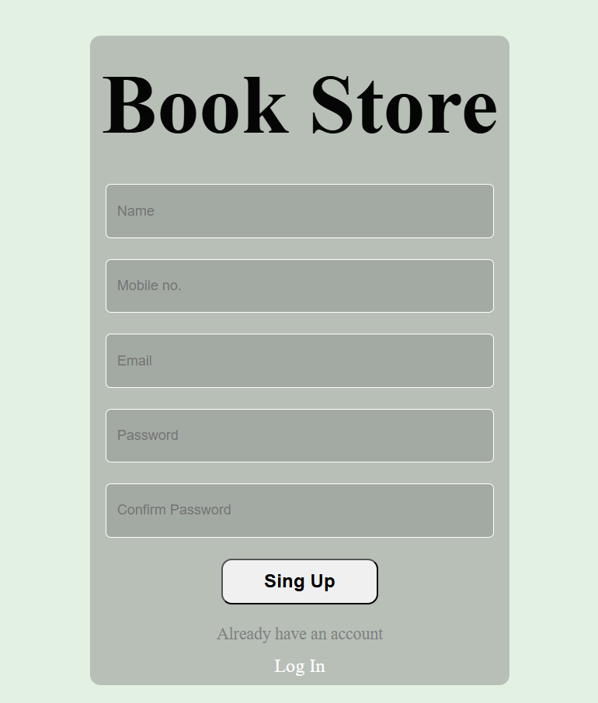
Output -

Cart page –
<!DOCTYPE html>
<html lang="en">

<head>
<meta charset="UTF-8">
<meta name="viewport" content="width=device-width, initial-scale=1.0">
<title>Cart</title>
<style>
* {
padding: 0;
margin: 0;
}

.header {
background-color: black;
color: white;
font-size: 30px;
display: flex;
justify-content: space;
}

.head {
font-weight: 600;
padding: 10px;
}

.cart {
padding-top: 13px;
padding-left: 10px;
}

.t1 {
font-size: 25px;
font-weight: 600;
padding: 10px;
}

.book {
width: 300px;
height: 470px;
border: 1px solid black;
margin: auto;
border-radius: 10px;
background-color: rgb(232, 232, 232);
display: flex;
flex-direction: column;
align-items: center;
gap: 5px;
margin-top: 10px;
margin-bottom: 10px;
}

img {
width: 240px;
border-radius: 10px;
}

.bookimg {
margin: 10px 30px;
}

.bookname {
font-size: 18px;
font-weight: 700;
}

.bookbtn {
background-color: black;
color: white;
padding: 10px;
border: 0px;
border-radius: 5px;
}

.bookbtn:hover {
background-color: white;
color: black;
font-weight: 700;
border: 2px solid black;
}

.booklast {
margin-bottom: 70px;
}

.grid {
display: grid;
grid-template-columns: 1fr 1fr 1fr;
}
</style>
</head>

<body>
<div class="con">
<div class="start">
<div class="header"> <svg class="cart" xmlns="http://www.w3.org/2000/svg" viewBox="0 0 24 24" width="28"
height="28" color="#ffffff" fill="none" stroke="#ffffff" stroke-width="2" stroke-linecap="round">
<path d="M8 16L16.7201 15.2733C19.4486 15.046 20.0611 14.45 20.3635 11.7289L21 6" />
<path d="M6 6H22" />
<circle cx="6" cy="20" r="2" />
<circle cx="17" cy="20" r="2" />
<path d="M8 20L15 20" />
<path
d="M2 2H2.966C3.91068 2 4.73414 2.62459 4.96326 3.51493L7.93852 15.0765C8.08887 15.6608 7.9602 16.2797 7.58824 16.7616L6.63213 18" />
</svg>
<div class="head">Your Cart</div>
</div>
<div class="t1">Your favourite collection - ready to buy</div>
<div class="grid">
<div class="card">
<div class="booklast book">
<div class="bookimg"> <img
src="https://media.springernature.com/full/springer-static/cover-hires/book/978-1-4842-9792-6">
</div>
<div class="bookname">Database-Driven Web Development</div>
<div class="bookauthor">Thomas Valentine</div>
<div> <button class="bookbtn">Buy Now</button> </div>
</div>
</div>
<div class="card">
<div class="booklast book">
<div class="bookimg"> <img
src="https://media.springernature.com/full/springer-static/cover-hires/book/978-1-4842-9792-6">
</div>
<div class="bookname">Database-Driven Web Development</div>
<div class="bookauthor">Thomas Valentine</div>
<div> <button class="bookbtn">Buy Now</button> </div>
</div>
</div>
<div class="card">
<div class="booklast book">
<div class="bookimg"> <img
src="https://media.springernature.com/full/springer-static/cover-hires/book/978-1-4842-9792-6">
</div>
<div class="bookname">Database-Driven Web Development</div>
<div class="bookauthor">Thomas Valentine</div>
<div> <button class="bookbtn">Buy Now</button> </div>
</div>
</div>
<div class="card">
<div class="booklast book">
<div class="bookimg"> <img
src="https://media.springernature.com/full/springer-static/cover-hires/book/978-1-4842-9792-6">
</div>
<div class="bookname">Database-Driven Web Development</div>
<div class="bookauthor">Thomas Valentine</div>
<div> <button class="bookbtn">Buy Now</button> </div>
</div>
</div>
<div class="card">
<div class="booklast book">
<div class="bookimg"> <img
src="https://media.springernature.com/full/springer-static/cover-hires/book/978-1-4842-9792-6">
</div>
<div class="bookname">Database-Driven Web Development</div>
<div class="bookauthor">Thomas Valentine</div>
<div> <button class="bookbtn">Buy Now</button> </div>
</div>
</div>
</div>
</div>
</div>
</body>

</html>

Output -


